|| Om Shri Sai ||
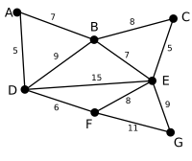 | This is our original graph. The numbers near the arcs indicate their weight. None of the arcs are highlighted.
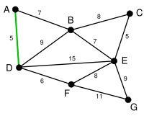 | AD and CE are the shortest arcs, with length 5, and AD has been arbitrarily chosen, so it is highlighted.
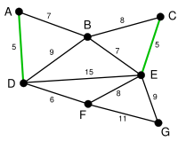 | CE is now the shortest arc that does not form a cycle, with length 5, so it is highlighted as the second arc.
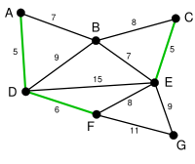 | The next arc, DF with length 6, is highlighted using much the same method.
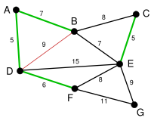 | The next-shortest arcs are AB and BE, both with length 7. AB is chosen arbitrarily, and is highlighted. The arc BD has been highlighted in red, because there already exists a path (in green) between B and D, so it would form a cycle (ABD) if it were chosen.
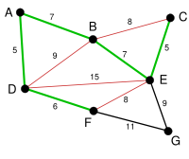 | The process continutes to highlight the next-smallest arc, BE with length 7. Many more arcs are highlighted in red at this stage: BC because it would form the loop BCE, DE because it would form the loop DEBA, and FE because it would form FEBAD.
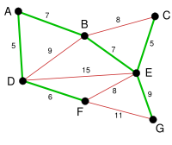 | Finally, the process finishes with the arc EG of length 9, and the minimum spanning tree is found.
Kruskal’s Method of finding Minimum spanning Tree
Que] To draw a binary tree whose inorder and post order is given
IN : BDEFAGCLJHK
POST : DFEBGLJKHCA
Ans] The program is same as taught in the class for IN and PREorder input. The only difference will be that instead of considering th e first element from the preorder sequence(preorder[0]),select the last element of post order sequence.

Heap Sort
A heap is an ordered binary tree where elements are inserted in an ordered manner. But this binary tree has a special condition that the info of root node is always greater than its left as well as right child. The left and right child may not be ordered (any of the child may be smaller or greater)
The heap sort method involves two basic operations:
- Creating a heap
b) To convert a heap into an array of elements in ascending order
The heap tree is best represented using the concept of arrays. The elements of heap tree are stored in the array from the 1st position instead of the 0th position. The 0th position of array contains the count of the no. of elements in the heap tree.
Hence, graphically heap tree is just like a binary tree where as implementation wise it is an array.
With respect to the array positions, the parent of any node can be calculated by accessing the “position/2” element, where as the child of any position can be referred by accessing “2 * position” and the “2 * position +1” element.
The application of a heap involves the restore heap up and restore heap down operations, where the elements are arranged from bottom to top or in top to bottom order.
Logic for Heap Sort : For heap sort, first the normal array is converted into a heap and then using the property of heap that the first element is the largest element in the heap, the elements of the heap are sorted.
- To convert an array into heap, we start from the last parent node( n/2 ) and go till the first parent and simultaneously restoring the heap downwards .
- Once the heap is created, the sorting begins. Select the first element of the heap as it contains the largest element, interchange it with the last position of the array, decrease the no. of elements of the heap by decreasing the value of ( a[0] ) . On each repetition, by decreasing a[0] we are eliminating the last element from the sort. This is repeated till a[0] is reduced to zero. Finally a[0] is reinitialized with the no. of elements in the heap.l

Strongly Connected Graph :
A connected graph is a graph such that there exists a path between all pairs of vertices. If the graph is a directed graph, and there exists a path from each vertex to every other vertex, then it is a strongly connected graph.
A connected component is a maximal (under inclusion) subset of vertices of any graph and any edges between them that forms a connected graph. Similarly, a strongly connected component is a maximal (under inclusion) subset of vertices of any digraph and any edges between them that forms a strongly connected graph. Any graph or digraph is a union of connected or strongly connected components, plus some edges to join the components together. Thus any graph can be decomposed into its connected or strongly connected components.
For example, the following graph and digraph are connected and strongly connected, respectively.
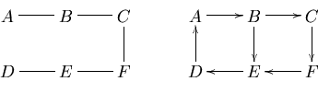
On the other hand, the following graph is not connected, and consists of the union of two connected components.
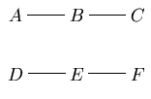
The following digraph is not strongly connected, because there is no way to reach from other vertices, and there is no vertex reachable from .
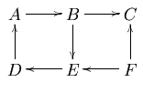
The three strongly connected components of this graph are
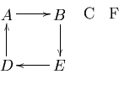

A digraph is strongly connected if every two vertices u and are reachable from each other, i.e. there is a directed path from to v and a directed path from to . Two vertices u and are strongly connected if they are reachable from each other. A Strongly Connected Component (SCC) of a digraph is a maximal subset of strongly connected vertices (Maximal in the sense that, if you add one more vertex from to the strongly connected component, the new larger set is not strongly connected anymore). If a digraph is not strongly connected, it can be decomposed into disjoint strongly connected components. The graph of following Figure has five strongly connected components.

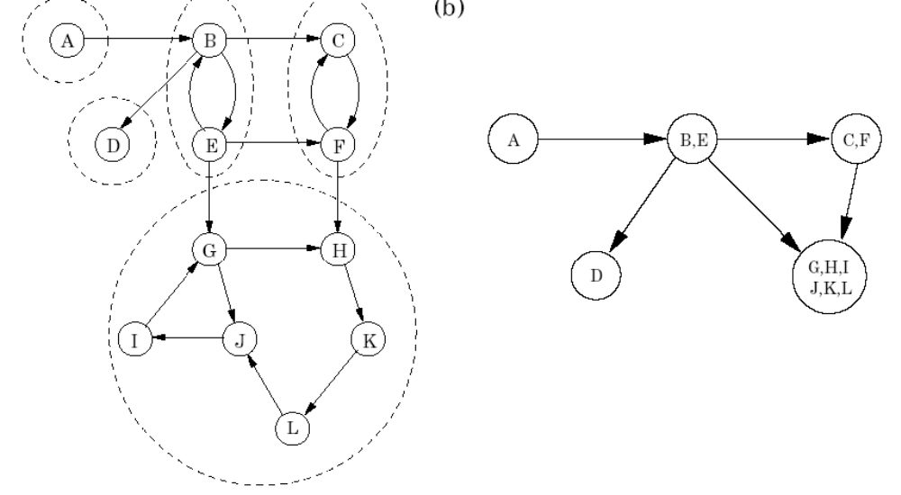

Minimum Spanning Trees

Spanning trees
A spanning tree of a graph is just a subgraph that contains all the vertices and is a tree. A graph may have many spanning trees; for instance the complete graph on four vertices
o---o
|\ /|
| X |
|/ \|
o---o
has sixteen spanning trees:
o---o o---o o o o---o
| | | | | |
| | | | | |
| | | | | |
o o o---o o---o o---o

o---o o o o o o o
\ / |\ / \ / \ /|
X | X X X |
/ \ |/ \ / \ / \|
o o o o o---o o o

o o o---o o o o---o
|\ | / | /| \
| \ | / | / | \
| \| / |/ | \
o o o---o o o o---o

o---o o o o o o---o
|\ | / \ | /|
| \ | / \ | / |
| \ |/ \| / |
o o o---o o---o o o

Minimum spanning trees
Now suppose the edges of the graph have weights or lengths. The weight of a tree is just the sum of weights of its edges. Obviously, different trees have different lengths. The problem: how to find the minimum length spanning tree?

Why minimum spanning trees?
The standard application is to a problem like phone network design. You have a business with several offices; you want to lease phone lines to connect them up with each other; and the phone company charges different amounts of money to connect different pairs of cities. You want a set of lines that connects all your offices with a minimum total cost. It should be a spanning tree, since if a network isn't a tree you can always remove some edges and save money.
A less obvious application is that the minimum spanning tree can be used to approximately solve the traveling salesman problem. A convenient formal way of defining this problem is to find the shortest path that visits each point at least once.
Note that if you have a path visiting all points exactly once, it's a special kind of tree. For instance in the example above, twelve of sixteen spanning trees are actually paths. If you have a path visiting some vertices more than once, you can always drop some edges to get a tree
Circular Link List :
In computer science, a linked list is a data structure that consists of a sequence of data records such that in each record there is a field that contains a reference (i.e., a link) to the next record in the sequence.

A linked list whose nodes contain two fields: an integer value and a link to the next node
In the last node of a list, the link field often contains a null reference, a special value that is interpreted by programs as meaning "there is no such node". A less common convention is to make it point to the first node of the list; in that case the list is said to be circular or circularly linked; otherwise it is said to be open or linear.
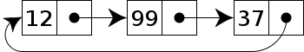
A circular linked list

